IP camera download page

Download
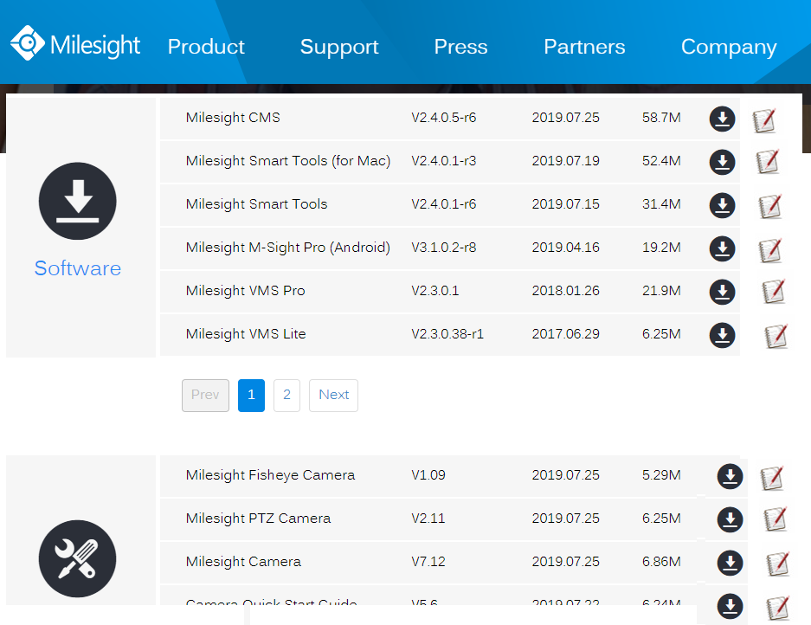
Datasheet
Description Version Released Date Size Download Note
- EPOC-151 Giga Ethernet/PoE over 2-Wire product series datasheet
V1.1
2018/02/19
1.32M
Note: The Giga Ethernet/PoE Extender Datasheet, the datasheet is including EPoC-151VA, EPOC-151PS, EPoC-151HP models.

- EPOC-131 Ethernet/PoE over 2-Wire product series datasheet
V2.1
2017/11/30
1.45M
Note: The Datasheet has been included EPOC-131VA(J/T), EPOC-EPOC-131PS(J/T), EPOC-131PS(J/T)-O and EPOC-131HP-O models.

- Ethernet over Coax product series datasheet
V2.1
2015/07/30
1.98M
Note: The Datasheet has been included EOC-100V, EOC-410V, EOC-100V models.

- Ethernet/PoE over 2-Wire case study profile
V1.0
2017/08/19
3.2M
Note: You can refer the EPoC product series application from this document file.
- EPoC_EoC Ethernet/PoE Extender systems presentation
V1.15
2017/08/15
3.1M

Software
- Join Group configuration software
V1.15
2017/05/15
1.5M
Note: This software supports Join Group function for Ethernet/PoE over 2-Wire extender product series which devices connect to the same cable to avoid the interference problem or encrypt 128 bits AES video.
Manual
- EPoC Join Group software operation manual
V1.2
2019/07/25
250.6K
Note. This manual suits for all EPoC over 2-wire product series to join a group with 128 bits AES encryption transmission which devices connect to the same cable.

- EPOC-151 product series hardware operation manual
V1.2
2018/05/13
250.6K
Note. This manual suits for all EPOC-151 product series.

- EPOC-131VAJ/ EPOC-131PSJ hardware operation manual
V1.2
2018/01/13
250.6K
Note. This manual suits for all EPOC-131VAJ/ EPOC-131PSJ product.

- EPOC-131VA/ EPOC-131PS hardware operation manual
V1.2
2016/08/09
250.6K
Note. This manual suits for all EPOC-131VA/ EPOC-131PS product.

- EPOC-131PS-O hardware operation manual
V1.3
2016/10/21
250.6K
Note. This manual suits for all EPOC-131PS-O product.

- EPOC-131PSJ-O hardware operation manual
V1.2
2016/08/09
250.6K
Note. This manual suits for all EPOC-131PSJ-O product.

- EPOC-131HP-O hardware operation manual
V1.3
2016/08/09
250.6K
Note. This manual suits for all EPOC-131HP-O product.

- EOC-110V Kit hardware operation manual
V1.5
2017/06/28
250.6K
Note. This manual suits for all EOC-110V product.

- EOC-100V-O hardware operation manual
V1.3
2019/07/18
250.6K
Note. This manual suits for all EOC-100V-O product.

- EOC-410V hardware operation manual
V1.4
2015/04/22
250.6K
Note. This manual suits for all EOC-410V product.

- EOC-100 Plus hardware operation manual
V1.4
2015/04/22
250.6K
Note. This manual suits for all EOC-100V Plus product.

